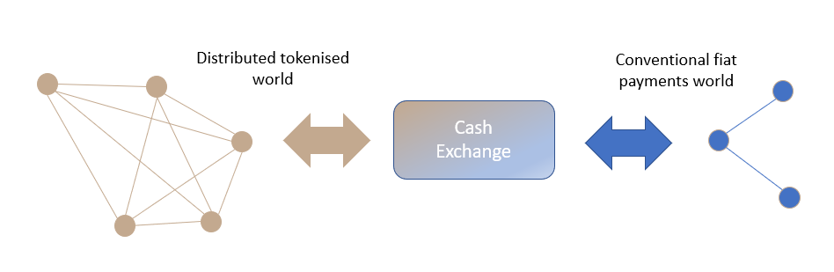

**Elevator Pitch**

FAC is looking for a partner to operate a new digital cash exchange service as part of its innovative distributed ledger-based platform for mutual funds servicing. Fund assets traded on the FAC platform are expected to exceed $100bn in five years making this a highly attractive ecosystem for digital service providers.

Acting as a gateway service, the cash exchange enables the transfer between on ledger digital tokens and real-world fiat cash.

The cash exchange will be a cornerstone of the platform delivering essential cash deposit and payment services to the fund managers, distributors and investors participating on the network.  The cash exchange operator will provide integrity, reliability and global scalability for the essential service of immobilising and digitising fiat cash deposits. The pool of collateral will ensure confidence in the cash tokens that are backed by these deposits.

The cash exchange operator would benefit from an opportunity to levy transaction fees and would optionally be able to generate additional revenue streams from enhanced services for FX, liquidity provision and possible yield enhancement through short term cash deposits, and rehypothecation of the collateral.

**Key Requirements**

* FAC needs to partner with an existing regulated, deposit-taking entity.
* The partner needs to bring payment processing and cash safekeeping capabilities that will be integrated to the FAC cash exchange.
* The cash exchange operator will provide both the conventional fiat cash payment and safekeeping services and will operate the on-ledger cash exchange node as the regulated issuer of FAC cash tokens.
* The FAC cash exchange operator will provide an automated, real time service to respond to requests for issuance or redemption of cash tokens and will process the corresponding fiat cash movements.
* FAC needs a partner prepared to take a long-term view of the potential opportunity, and who will work with FAC during our pilot and prelaunch phases to evolve the cash exchange to a ‘ready-for-production’ state.
* The initial focus will UK/GBP-only, but our aspirations are to support future expansion into European, APAC and US markets with support for multiple currencies

**Further Information**

FAC aims to operate as a market platform for investors and mutual fund providers to transact together.  FAC is built using innovative distributed ledger technology on which both funds and cash are represented as digital tokens, allowing for faster, risk-free settlement.  This creates a requirement for a cash exchange that can convert fiat currency to and from cash tokens and integrate the FAC network to conventional banking and payment services.  The cash exchange is a network service providing facilities to all participants of the network.

The cash exchange operates a node on the FAC network which is responsible for issuing and redeeming cash tokens and maintaining a record of all tokens issued.  This node will need to be integrated into a conventional bank account and payments service for off-ledger transfers.  The cash exchange operator is responsible for operating both the conventional and on-ledger parts of the process, ensuring a strict 1:1 relationship between fiat cash collateral and tokens issued on the network.

The exchange process is expected to be highly automated with workflows for processing receipts and payments through the exchange and maintaining the reconciliation.  A supporting customer service function would be necessary to resolve any errors or queries raised by FAC users.  The cash exchange operator would be required to have the appropriate authorisations from the UK Financial Regulators to operate the services described.

The cash exchange operator would enjoy a range of commercial opportunities. While incentivising the retention of cash on-ledger, it could to levy transaction fees. Beyond fee income, it could leverage additional revenue streams from FX, liquidity provision, yield enhancement through short term cash deposits, and rehypothecation of the cash collateral.

